**FIT – Barcelona, Valencia, Sevilla, Madrid**

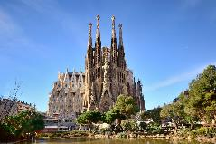 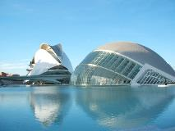 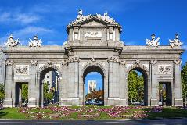 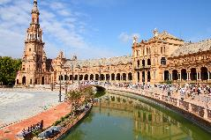

**day 1 Barcelona**

**private transfer** from Barcelona airport to the hotel in Barcelona.

**Barcelona** **sightseeing** based on a hop on- hop off bus.

*the key sights and world famous attractions of this fantastic city are included on the tour including* ***the gothic quarter*** *which is the centre of the old city of Barcelona. a great number of buildings are world heritage sites. especially remarkable is the work of architect* ***Antoni Gaudi****, which can be seen throughout the city;*  ***the Sagrada Familia cathedral, Casa Batlló, Casa Mila and Park Güell.***

overnight at hotel in Barcelona.

**day 2 Barcelona**

breakfast at the hotel.

half day **excursion in** **Montserrat**.

*Montserrat, the holy mountain, with weird shapes and rounded peaks that jut into the sky offering impressive views. an almost 1000 year old monastery hosts the oldest boys' choir in Europe. (located 1 hour driving from Barcelona.)*

overnight at hotel in Barcelona.

**day 3 Barcelona and Valencia**

breakfast at the hotel and check out.

**private transfer** to Barcelona train station to take the train to Valencia. **private transfer** from Valencia train station to hotel.

**leisure time** to discover the city, to go shopping or to go to the beach.

overnight at hotel in Valencia.

**day 4 Valencia and Sevilla**

breakfast at the hotel and check out.

**Valencia sightseeing** based on a hop on- hop off bus.

*explore Valencia starting from* ***Plaza del Ayuntamiento*** *(town hall square), central market, former* ***silk******exchange “La Lonja”,******Plaza de la Reina****, cathedral, Miguelete bell tower****, Turia river bed gardens, City of Arts & Sciences…***

**private transfer** to Valencia train station to take the train to Sevilla.   
**private transfer** from Sevilla train station to hotel.

**leisure time** to spend the evening enjoying the city.

overnight at hotel in Sevilla.

**day 5 Sevilla**

breakfast at the hotel.

**Sevilla** **sightseeing** based on a hop on hop off bus.

*the tour starts at the Isla de la Cartuja which was chosen as the site for the Expo’92, an appropriate reflection of the world at the end of the 20th century. laid out in 1929 for the Ibero-American exhibition,* ***the Plaza de España*** *and the adjoining* ***Maria Luisa Park*** *are among the most pleasant and impressive public spaces in Spain.*

overnight at hotel in Sevilla.

**day 6 Sevilla and Madrid**

breakfast at the hotel and check out.

**transfer** to Sevilla train station to take the train to Madrid.   
**private transfer** from Madrid train station to hotel.

**Madrid sightseeing** based on a hop on hop off bus.

*the tour highlights show the history of the city from the old Habsburg and bourbons quarters to the present city: Gran Vía, plaza de España, University, Moncloa, Habsburg old quarter, Calle Mayor, Puerta del Sol, Puerta de Alcalá, and the* ***Real Madrid stadium, Santiago Bernabeu*** *(tour of the stadium available).*

overnight at hotel in Madrid.

**day 7 Madrid**

breakfast at the hotel.

**Toledo excursion** on regular basis.

***Toledo*** *is one of the Spanish cities with the greatest wealth of monuments. known as the “city of the three cultures”, because* ***Christians, Arabs and Jews lived together*** *there for centuries, Toledo is a cultural jewel declared a world heritage site.*

*Toledo distance: 70 km from Madrid.*

overnight at hotel in Madrid.

**day 8 Madrid**

breakfast at the hotel and check out.

leisure time to enjoy the city. go shopping on the lively Calle Fuencarral or Gran Via to finish your trip in style.

departure transfer to Madrid airport.

**end of services**

**prices**

|  |  |  |  |
| --- | --- | --- | --- |
| **price per person & package** | **Nov - Mar** | **Apr - Oct** | **Jul - Aug** |
| **standard class** | **705 €** | **790 €** | **735 €** |
| child standard price  (up to 11 yrs) | **250 €** | **255 €** | **250 €** |
| single supplement | **230 €** | **280 €** | **260 €** |
| **first class** | **755 €** | **855 €** | **785 €** |
| child first price  (up to 11 yrs) | **206 €** | **225 €** | **225 €** |
| single supplement | **270 €** | **360 €** | **296 €** |
| **superior class** | **970 €** | **1.155 €** | **1005 €** |
| child superior price  (up to 11 yrs) | **305 €** | **325 €** | **305 €** |
| single supplement | **435 €** | **595 €** | **465 €** |

* prices per person based on double room & bb basis. taxes included. prices valid for minimum 2 traveling pax. prices for children sharing room with 2 adults.

* prices subject to availability and possible fluctuations in any of the requested services at the time of final booking

**validity**: **until October 2020.**

inclusions:

|  |  |  |  |  |
| --- | --- | --- | --- | --- |
| **city & nights** | **transfers** | **sightseeing** | **meals** | **24h. phone**  **assistance** |
| **2n Barcelona** | private  apt-htl-station | hop on hop off bus  half day Montserrat excursion | breakfast |
| **2n Madrid** | private station-htl-apt | hop on hop off bus  half day Toledo excursion | breakfast |
| **2n Sevilla** | private station-htl-station | hop on hop off bus | breakfast |
| **1n Valencia** | private station-htl-station | hop on hop off bus | breakfast |

prices do not include:

* regional tourist tax.
* tips and guests’ extras.
* any other service not mentioned on the programme / itinerary described.
* train tickets, please find supplements below:
  + *EUROMED train Barcelona – Valencia:  
    per person on tourist class:* ***from 46 €*** *(+ 4% handling fee)*
  + *AVE high speed train Valencia – Sevilla:  
    per person on tourist class:* ***from 93,60 €*** *(+ 4% handling fee)*
  + *AVE high speed train Sevilla - Madrid:  
    per person on tourist class:* ***from 76,50 €*** *(+ 4% handling fee)*
* **transportation to sightseeing meeting points is not included, we recommend the use of public transportation or taxi.**

**optional supplements**:

|  |  |  |
| --- | --- | --- |
| C:\Users\marketing2\Downloads\camp-nou.jpg  **football tickets**  **on request** (prices average 48-250 €) | C:\Users\marketing2\Downloads\Camp02.jpg  **Barça – Camp Nou stadium tour**  adult: 26 € child (6-13): 21 €  *\*with time and date given* | C:\Users\marketing2\AppData\Local\Microsoft\Windows\INetCache\Content.Word\madrid-entrada-santiago-bernabeu.jpg  **Real Madrid stadium tour**  adult: 25 € child (6-13):18 € |
| C:\Users\marketing2\AppData\Local\Microsoft\Windows\INetCache\Content.Word\Flamenco-Madrid-400x300.jpg  **flamenco show & dinner in Madrid or Barcelona**  adult: from 50 € (vegetarian menu and special menu for children available) | C:\Users\marketing2\Downloads\flamenco-sevilla.jpg  **flamenco show & drink in Sevilla**  from 28 € | C:\Users\marketing2\Downloads\cordoba.jpg  **full day Córdoba from Sevilla**  105 € |
| C:\Users\marketing2\Downloads\crucero-por-el-guadalquivir-1000-1000x580.jpg  **Guadalquivir cruise** 1h duration  adults: 16€ children (0-12): free | C:\Users\marketing2\Downloads\1-e1510611885889.jpg  **Segway in Valencia**  from 33€ |  |

* prices per person.

**itinerary & number of nights**

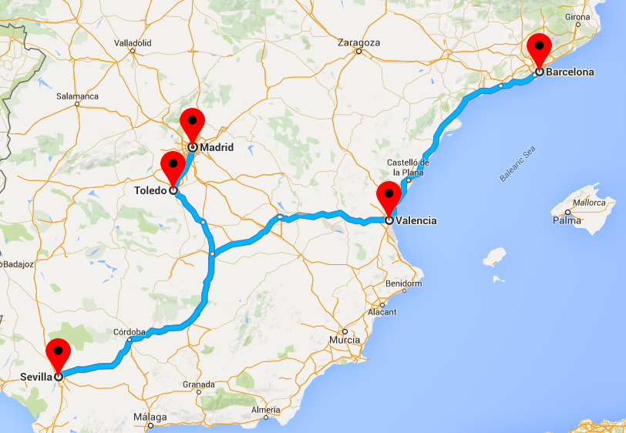

**1n**

**Valencia**

**2n**

**Barcelona**

**2n**

**Sevilla**

**2n**

**Madrid**